STUDENT Joseph Roper

Salford City College | [Company address]

BTEC National Extended Diploma in Creative Media Production

Unit 6: Critical Approaches

Unit 6 – Task 2

# Marketing Techniques

Marketers use images, sound, words, symbols and icons to appeal to specific audiences so that they can market their product more effectively.

Images are a very effective marketing tool as it is usually the first piece of media that the audience will see for your product meaning it will set how the audience will portray your product after the fact. An example of an effective piece of media demonstrating the relevance of imagery in marketing is the Super Smash Bros Ultimate poster as it shows off every character in the game which will allow the audience to recognise the characters they know from other games and franchises intriguing them to purchase the game. This poster is also using symbols and icons as they have Mario, Link and Pikachu all Nintendo franchise frontrunners making them easily recognisable to audiences.

[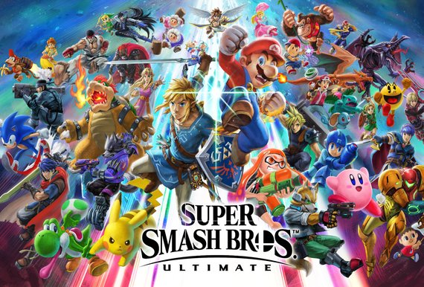](https://www.etsy.com/au/listing/606806072/super-smash-bros-ultimate-poster-13x19)

Sound is an effective marketing tool as it can be used to set the tone for a product and invigorate audiences to see the rest of a trailer in a good light persuading them more to purchase the product. A good use of sound in a trailer is for the story mode of the game Super Smash Brothers Ultimate: World of Light as the song used in the trailer truly immerses the audience into the trailer, the song’s lyrics also inform the audience about the context of the story mode.

<https://www.youtube.com/watch?v=WShCN-AYHqA>

The text on posters is also important as it displays the title of the game and without it there would just be an image and audiences wouldn’t know what the product is called meaning they wouldn’t be able to research the product and buy it. The font is also important for the title of a poster as if the text was really small you wouldn’t be able to read it and if it was too big the text would block the image resulting in a bad poster.

Marketers use selective language to entice their audience to buy a certain product and slander others. They will use powerful words such as elite, faster, better and stronger to describe for example a computer and its positive attributes and then when describing the negatives of the computer they will use euphemisms to make the bad points of the system seem better than they are for example in the 16-bit console war between SEGA and Nintendo each company used marketing tricks to get the better of the rival company, an example of this is with the SEGA Mega drive vs the SNES (Super Nintendo Entertainment System). The SNES overall debatably had better hardware than SEGA’s system, however SEGA didn’t advertise it this way they instead called their weaker processor the “Blast Processor” and had adverts that compared the SNES to a slow car and the SEGA Mega drive to a super car. This would influence young children, with the budget to only buy one console which is most likely SEGA’s target market, to buy the console that is compared to the really fast car as children like fast cars.

[](https://www.youtube.com/watch?v=zlulSyBI2aY)

^SNES^ ^SEGA Mega drive^

<https://www.youtube.com/watch?v=zlulSyBI2aY>

# Audience Profiling

I am going to try and guess the; age, gender, regional identity, socio economic status, psychographics and gaming preferences of the fans of the game franchise Super Smash Brothers just off of the marketing for the game. For the age of their fans/players of the game I will assume its 12 - 25 considering that it is a fighting game it should be for an older audience such as 15+ however there is no blood in the game and it uses Nintendo’s characters such as Mario and Pikachu so it can be played by children as it only contains cartoon violence.

For the gender of the players I believe it will most likely be male as it’s a fighting game and most of the characters in the game are male as well as the people in the adverts playing the game are usually male. However I believe females also play it due to the character roster having pink characters like princess peach and Kirby. Also because all the adverts try to include a 1:2 or 2:6 ratio of female to males so Nintendo is clearly trying to market more to males but also somewhat of the other gender too.

[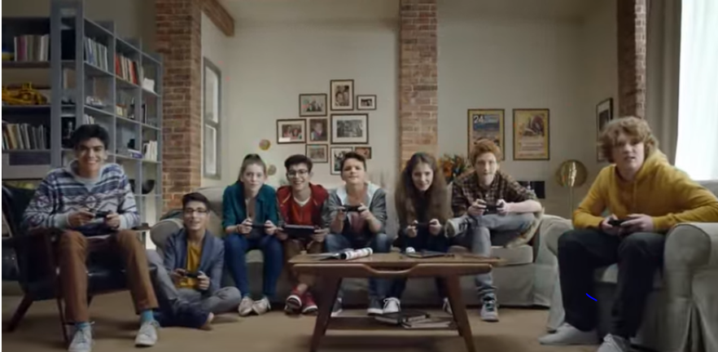](https://www.youtube.com/watch?v=j_WDbgOku9w)

[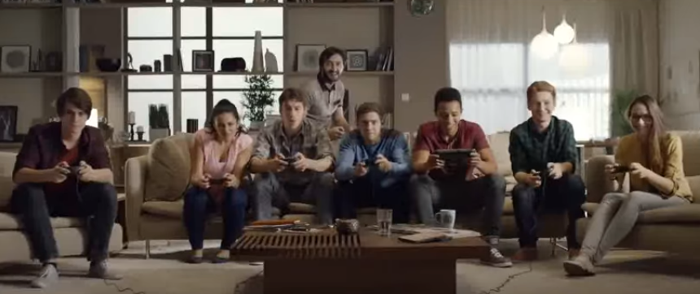](https://www.youtube.com/watch?v=j_WDbgOku9w)

I believe most of the players for this game rather live in Japan or English speaking countries as all of the marketing is rather in English or Japanese meaning that you’ll only find out about the game if you're rather a massive fan of Nintendo or you see and advert in one of those countries.

I think the socio economic status of the players is middle class to upper class as to play the game which was released at the price of £40 you also have to own the Wii U console which is roughly £300 brand new, meaning people without money won’t want to spend money on a console with only a few good games and which doesn’t really receive 3rd party games.

I believe people who play Super Smash Brothers Wii U will also like other fighting games due to the genre of the game or other Nintendo games as they play Smash because their favourite characters are in the game.

As super smash brothers is meant to be a family game it should cover all of the gaming psychographics to appeal to the whole “family” which I think it does as it obvious covers action and achievement because it is a fighting game meaning the goal is to win (Achievement) by beating up your opponent through punches kicks and explosions (Action). It also covers social as you can play against your friends and mastery as it can be a competitive game by going to competitions to win money which you will need to practice a lot for. Finally it covers creativity as the game is about getting characters from different games and finding out who will win in a fight and lastly immersion as you get to play as someone else and as in Super Smash Brothers Brawl there was a really good story mode.[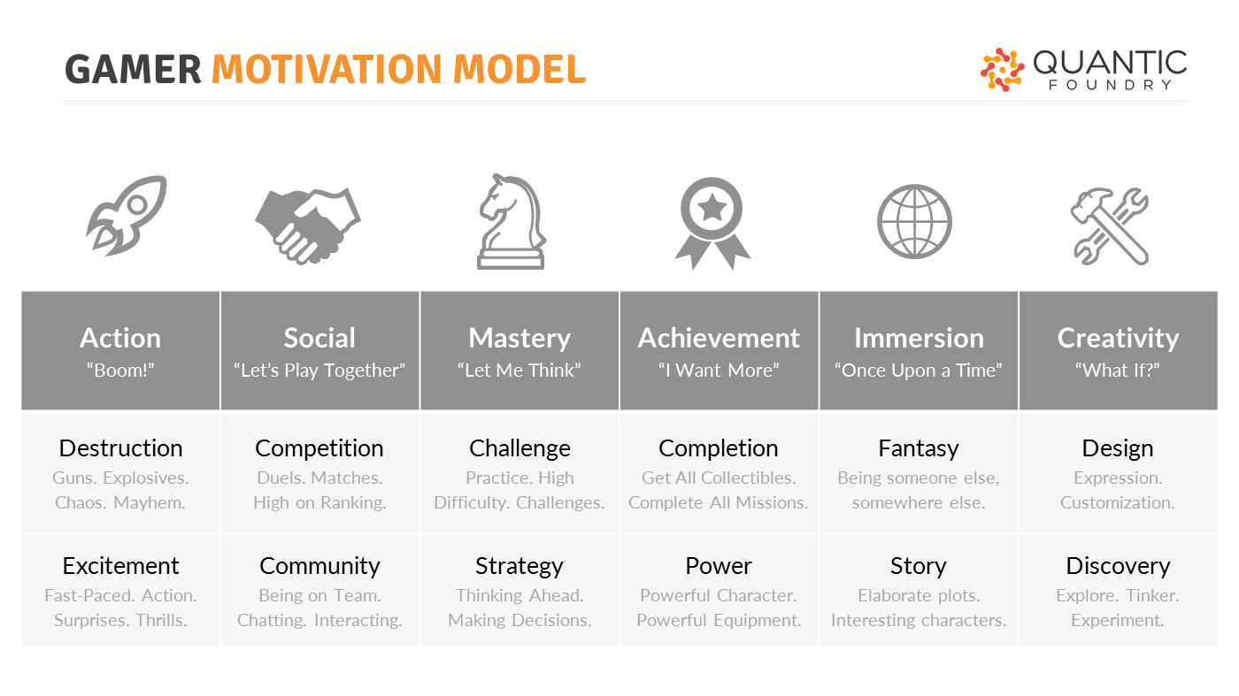](https://quanticfoundry.com/2017/08/29/just-important-female-protagonists/)

As you can see audience profiling can be incredibly useful for developers because you can find out your target audiences; age, gender, where they live, the language they speak, their economic status and psychographics. With this information you can find out the exact type of people you should market too and where you should market your game. For example if my game is like World of Warcraft and I know most of the audience for that game is 35 year old males, overweight and in English speaking I can work out that I should advertise my game in America and England because they are English speaking countries and contain a high amount of obese and overweight people with the popularity of fast food restaurants, I should also advertise my game on the internet because overweight people spend more time on the internet usually than going outside. I would put my advert on YouTube and select it so it is more likely to play the game on World of Warcraft gaming videos. Also because my target audience is for adult males I will have my adverts contain violence to attract them to play the game. Now this may seem really mean and seem like I’m almost invading someone’s privacy but this is what massive gaming companies marketing teams think of and do, because it works.

# Audience Feedback

When an audience are unhappy with a product they have a lot of options to reach out to the company involved; they could call the companies phone number, write to the companies address or email address, go on the app store (If it is an app) and write a bad review, they could reach out to one of their communities and complain or go on social media websites such as Twitter and do it. I believe the most effective methods are calling the company up directly or using social media and getting other people with the issue to try and reach out to the company as a crowd will raise more attention to the company that it is an issue that needs to be fixed. Personally I had a problem with the MTickets app which I use to buy bus tickets so that I can get to college, the issue was that the app isn't allowing me to buy tickets so I looked at the apps reviews on the google play store to see if anyone was having the same problem and they were but it seemed like the issue was not being resolved so I called the support team of the app and asked them about the issue and apparently they had no other cases involving the same issue so I stated that there were a lot of reviews containing information about my same problem which apparently they didn’t know about they then said they would look at the reviews and try to resolve the problem. So this is one example of how an audience can let a company know if they are having problems with their service. What I have learned from this is that if I ever owned a business that provided a service for example a restaurant I would read reviews and try and fix issues people are having with my product.

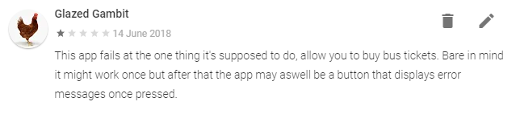

Another way of having audience feedback is through running game betas and PTR’s (Public Test Region), where the public can play an early version of your game and then leave feedback containing bugs/glitches in the game as well as how it could be improved. An example of this is with the Overwatch PTR as they have a frequently active discord and Reddit page, where the players of the game can post bugs in the game with a description of how it was caused. Then a developer of the game will look at it and reply for further information to then fix the game. Unlike EA when they will only listen to their fans when there is a massive backlash and the media gets involved for instance what happened with the Battlefront 2 game where they added micro transactions for loot boxes in a £50-pound game. The video above this paragraph explains why this is such a problem. From this I have learnt that it is good to allow people to test your games and then listen to their feedback, this will then result in a thriving community of happy fans.

[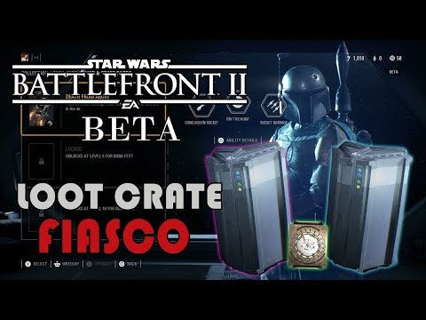](https://www.youtube.com/watch?v=txdY6fzjef8)[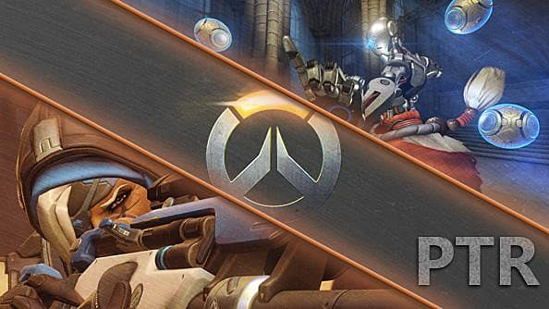](https://www.gameskinny.com/89iv1/how-to-join-overwatch-ptr)

# Survey Feedback

I made a Survey with Microsoft Forms about how Nintendo market their game franchise Super Smash Brothers. I then sent this to students in my course and a couple of friends to find out their views on the marketing material for Super Smash Brothers.

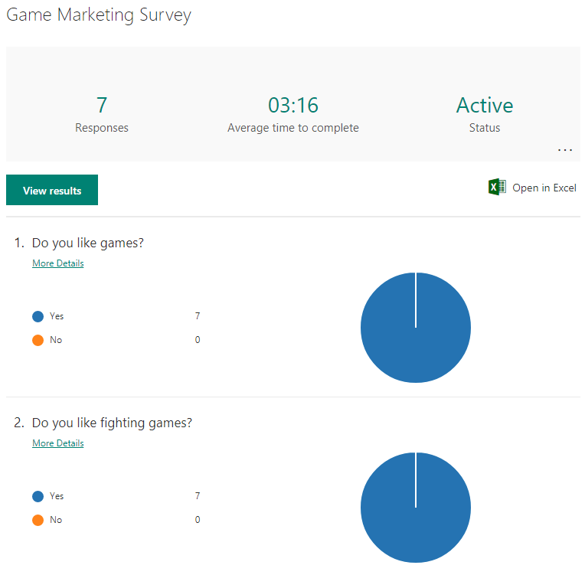

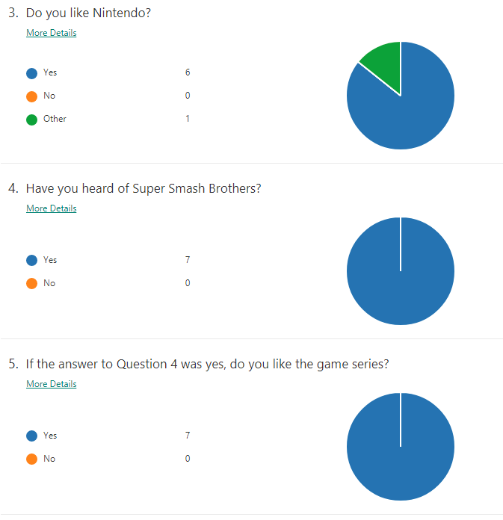

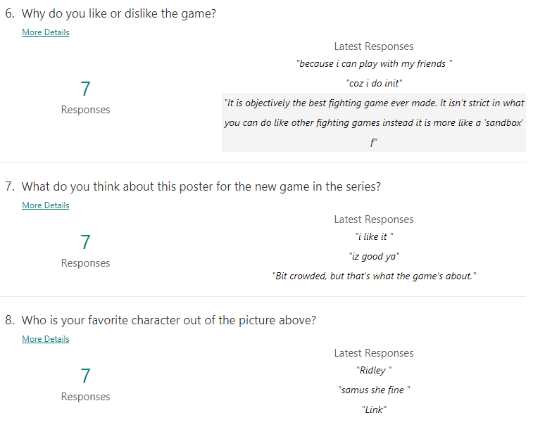

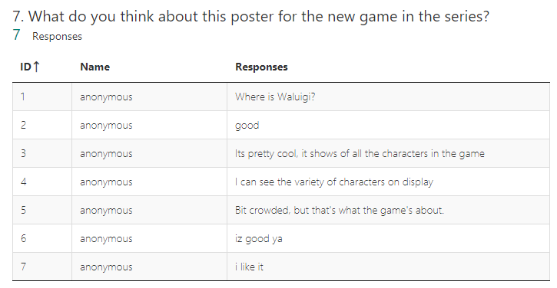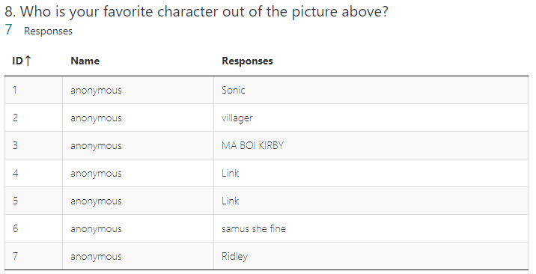

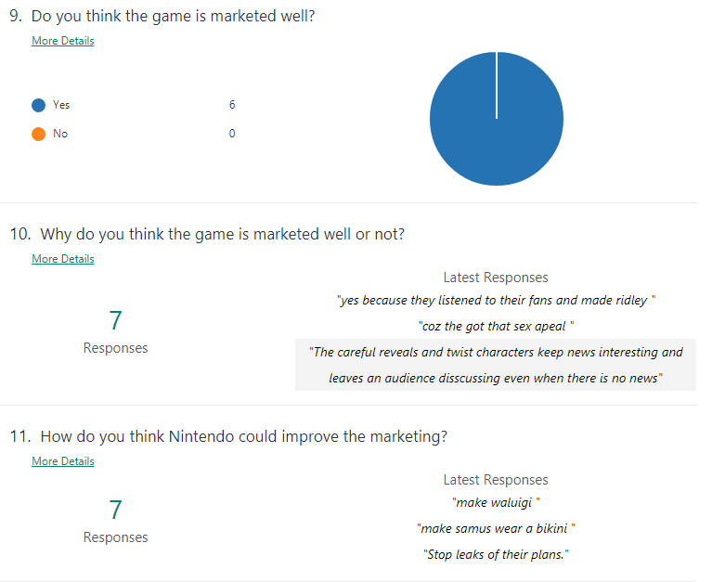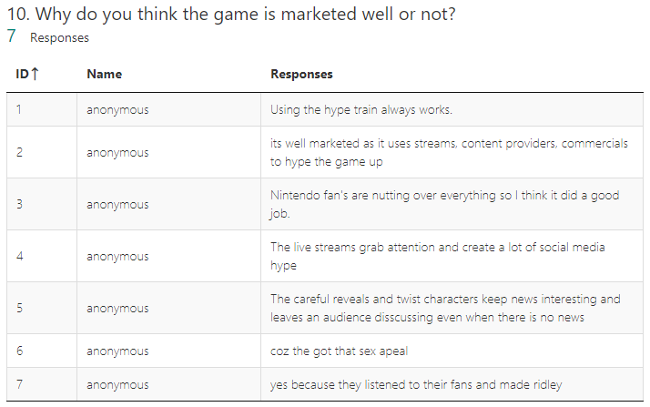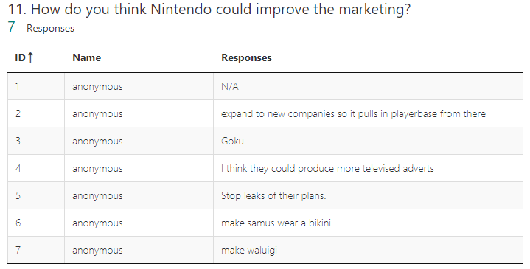

The first 2 questions were made to get rid of any anomalies in the survey gladly there were no anomalies as every participant answered that they were a fan of games and the fighting games genre.

Based on the results I got I can tell that most people have a positive view on Nintendo as a company, their games and how they promote them as all of the responses were positive saying that the promotional material for the game is produced well as it tries to show of all the characters in the game evenly throughout the material as to not create a bias in the fandom. Overall to improve on Nintendo’s marketing based on the results I got I would produce more video adverts and play these on various social media websites such as YouTube, Twitch, Twitter and Facebook. This would expand the companies reach on audiences and potentially bring in more fans. I also think Nintendo should tighten up their security as information about the game is always leaked (posted without the intention of the company) when in-depth trailers are about to release for the game. Personally I don’t think Nintendo have been listening to their fans as well as they should be as they held a Ballot on who should be in the next game and a character called Waluigi was a big contender in the ballot and yet he hasn’t been put into the new game.

